Release Details
Client - Keenan & Associates
Track - CBMS
Release Month - July 2012
Release Version - 6.1.10
Sprint # - June Sprint2
Scrum Master - Seshan

Sprint Goal
- Complete planned sprint items

Sprint Scope – Plan
Ticket ID/  User Story ID | Ticket Details/User Story Name | Planned  Story Points
9816 | Enable "next year" feature option for Type 3 plans | 83
9452 | Enhance Volume Based Bills | 12
10138 | Fix issues with voluntary workflow | 8
10137 | Add dropdown hints to rule builder (Voluntary workflow) | 20

Sprint Scope - Actual
Ticket ID/  User Story ID | Ticket Details/User Story Name | Actual  Story Points
9816 | Enable "next year" feature option for Type 3 plans | 0
9452 | Enhance Volume Based Bills | 12
10138 | Fix issues with voluntary workflow | 8
10137 | Add dropdown hints to rule builder (Voluntary workflow) | 10
9837 | Add dropdown hints to rule builder (Voluntary workflow | 5

Red denotes de-scoped in Sprint

Estimated Velocity: 123 SP {0.66 (Story point per hour)}. 186 Hours for Sprint
Actual Velocity: 35 SP {0.23 (Story Point per hour) }. 148 Hours for Sprint

Note:
- Development hours are not constant across the sprints, due to this, velocity is in terms of SP per hour
- 9452: The complexity was underestimated and team spent more hours in completing the work than planned.
- 10137: Is not complete and SP is taken based on 50:50 rule.
- Previous cycle SP estimation was done without detailed discussion and hence the # of SPs were more, which reflects higher velocity in previous cycle.
- Previous sprint team spent more hours in development but they did not report correct hours, which reflects as higher velocity in previous cycle
- 9816: The original estimate of 9816 needed to be de-scoped since the requirement needed more details and development is pending clarification. In technical spike we lost 22 hours.

Sprint Timelines
First Day of Sprint | 06/25/2012
Last Day of Sprint | 07/05/2012
No of Working Days in Sprint | 9

Resource Details
Name of Team member | Planned no of days | Planned SDLC Utilization
Senthil Sai | 9 | 60%
Padmanabhan | 9 | 55%
Allwin | 9 | 40%
Darrell | 9 | 70%
Sugumar | 9 | 70%
Ashwin | 9 | 30%
Ramesh Ganji | 9 | 10%

Agile Metrics

- Sprint Burn down chart
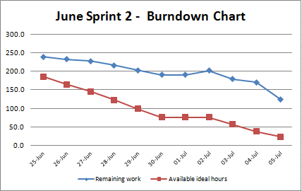

- Defects Metrics

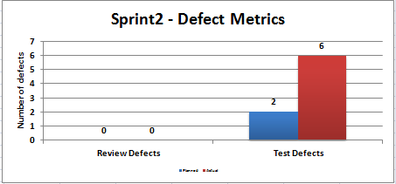
6 defects are internal defects. 1 defect leaked to the customer

- SVN Build Report – Not Available

- First Time Right

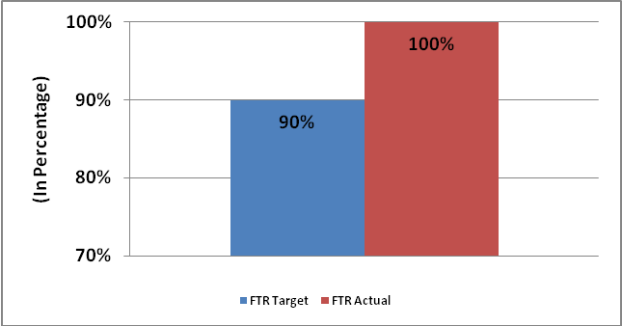

Process Overview
What went well?

- Updating the Sprint / Support hours
- Work distribution among team
- Keep documenting the solution of the problem in squish system
- Team collaboration
- Standup meeting regularized
- Daily Status updates were being sent.
- Resources availability planning was good.
- Team participated in Poker Estimation.
- Hot fixes rollout was smooth.
- Processes refined and reviewed by the stakeholders

What could have been better?

- Impact analysis to be done before estimation
- QA to check with originator / PO / PPO on clarifications on requirements/test case review in the beginning. In case of no response coming immediately (if Originator / PO / PPO are busy). Then QA can send email reminder, setup meeting / call and get clarity.
- QA should develop test cases from acceptance criteria given by originator or customer.
- Unique ranking to be provided by PO or PPO on work items for Sprint Planning

- Areas of improvement
- Requirement needs to be finalized before Sprint planning.
  - Regular refresh of QA data
  - Once the consolidating the product backlog is done in TFS, then TFS may be used in parallel for tracking Sprint progress.
  - Unique ranking of work items to be provided in Squish / TFS
  - Report generation can be checked from TFS, once scrum team starts updating daily updates in TFS and Template. Once the report reflects similar to current customer requested template and agreed by all stakeholders, then team may consider TFS the primary update system.
  - QA Release Plan to be provided and updated by dev team
  - QA Status to be updated in Sprint Backlog by QC team
  - Update the status of items in TFS and squish on progress of items
  - Update of spike hours needs to be done by team

- Issues to escalate to Sr. Management
  - N/A

Action Items
ID | Action Item | Owner
1 | Requirement clarifications need to be raised in the beginning of the Sprint | Scrum Team
2 | Squish tickets needs to be finalized before Sprint planning and uniquely ranked | Darrell (Proxy PO)
3 | Update of sprint backlog with actual hours every day. They need to enter the estimates in the in sprint backlog while sprint planning. | Scrum Team
4 | User Story and test case to be reviewed | Originator / PO / Proxy PO
5 | QA Release Plan to be provided and updated by dev team | Scrum Team (Dev)
6 | QA Status to be updated in Sprint Backlog | Scrum Team (QA)
7 | Update of spike hours needs to be done | Scrum Team
8 | Review Report generation from TFS, once scrum team starts updating daily in TFS and Template | Scrum Master / Scrum Team

